Swap CM serving an Active Subscriber

Version Control:

Use Case Name: |  | Swap CM serving an Active Subscriber
Use Case Owner: |  | Abhishek Bhalerao
Current Version |  | 0.3
Use Case Version History
Modified Date | Version |  | Modified By | Change Description
June 28, 2009 | 0.1 |  | Tom Schnarr | Initial Version
August 26,2009 | 0.2 |  | Sumit Borade | Updated to add the reply path and removed the steps not relevant to SMP.
October 28,2009 | 0.3 |  | Sumit Borade | Updated the Description of the Steps

Brief Description:
This use case describes the process by which the CM (which may be an EMTA) device is swapped for an active customer.

The use case is written from the perspective of the SMP provisioning solution.

Related Documents
- YouSee SMP SOW2Architecture Requirements Document
- YouSee SMP SOW2 Business Requirements Document
- Cisco BACC TC Specification

Related Use Cases

Pre-Conditions
- Subscriber is an active broadband subscriber

Post-Conditions
- Subscriber is free to use Broadband over Cable service from the new CM, and the old CM is deprovisioned

Use Case

Primary Flow Diagram
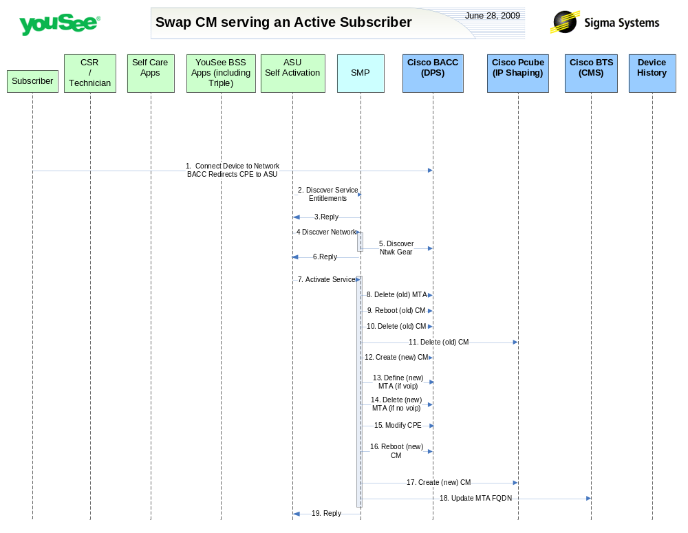

Primary Flow Detail
# | Actor: Key Action | Description | Alternate Flows/Details
 | Subscriber: connects new CM to PC and launches a browser. Network (BACC) redirects browser to ASU | The Subscriber connects new CM to network along with PC. The new device will be assigned an IP from BACC RDU which redirects user to ASU registration portal.
 | ASU: request service entitlements from SMP | <As in Activate Broadband Use Case>
 | SMP: SMP sends reply to ASU for Service Entitlement Information | SMP will reply to ASU the Services present in SMP for that particular account.
 | ASU: requests SMP to discover network gear | <As in Activate Broadband Use Case>
 | SMP: queries BACC and internal inventory to find network gear serving subscriber | <As in Activate Broadband Use Case>
 | SMP: Replies back to ASU the information received from CISCO BACC | SMP will reply back to ASU information retrieved from CISCO BACC for CPE IP address.
 | ASU: requests SMP to activate service | ASU will request SMP to activate service by generating an order in SMP assigning the CPE MAC to the appropriate service.
 | SMP: deletes old MTA from BACC | SMP will deprovision the old MTA from BACC (assuming the device previously had VoIP service)
 | SMP: requests BACC to reboot the CM Device | Device is rebooted resulting in it receiving the new configuration.  This needs to occur prior to the CM deletion from BACC as BACC cannot reset a deleted device. This introduces a minor timing issue, but for the vast majority the device is deleted from BACC before it completes the reboot cycle.
 | SMP: deletes old CM from BACC | SMP will deprovision the old CM from BACC
 | SMP: removes old broadband service from CISCO Subscriber Manager | <As in Deactivate Broadband Use Case>
 | SMP: creates new CM in BACC | SMP will provision the new CM in BACC with the appropriate configuration for services they are entitled to
 | SMP: defines new MTA in BACC | SMP will provision the new MTA in BACC with the appropriate configuration for services they are entitled to – that is if they are entitled to VoIP from this device
 | SMP: deletes new MTA from BACC | If the subscriber is not entitled to VoIP, then the MTA is removed from BACC
 | SMP:modifies configuration of CPE | If the configuration of the CPE contains a reference the corresponding CM MAC, then the service is updated. This is done for each CPE service where a MAC is assigned.
 | SMP: requests BACC to reboot the new CM Device | <As in Activate Broadband Use Case>
 | SMP: defines new broadband service from CISCO Subscriber Manager | <As in Activate Broadband Use Case>
 | SMP: updates FQDN in BTS | If the subscriber is entitled to voice services, the BTS needs to be updated with the FQDN of the new MTA for this voiceline.
 | SMP: Replies back to ASU the status of Activation | SMP will reply to ASU the status of Provisioning Order to ASU. | If Provisioning fails then SMP will put the Failed task in Manual Queue.

